1. We started by adding the env variables, the new one to the vercel

1. We then made the user button component

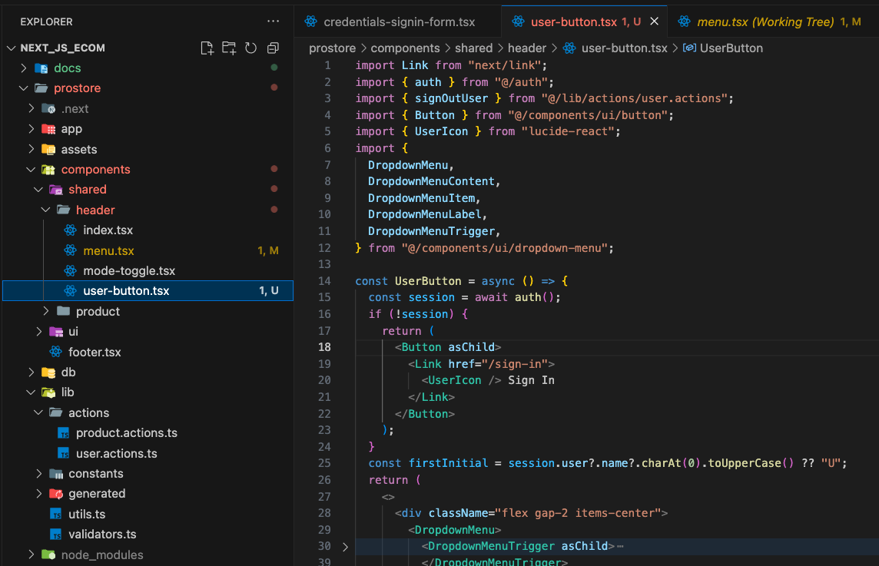

And updated the action



There is error because we are not using what that returns

1. Now we replace the old button with this new user button

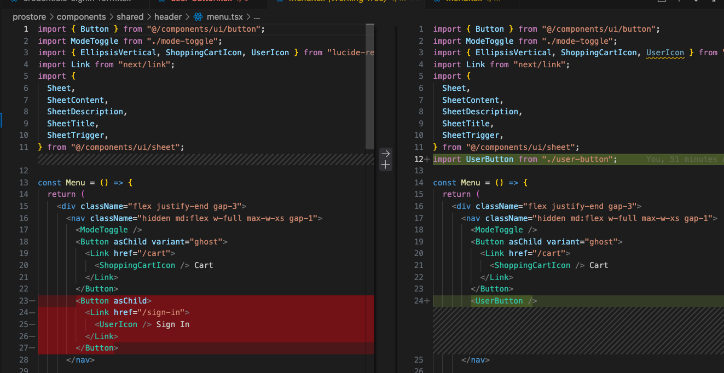

1. But this cause deployment issue and we must comment out the return for now.

